**Chapter 4. Results and Analysis**

**Models’ predictive performance:**

Both the models showed good predictive capabilities, performing equally well on both training and test data with no indication of overfitting, especially the model developed for tensile strength predictions.

The prediction quality on unseen data can be observed (in fig) where we observe that the predicted values are awfully close to the actual values with only slight error for majority of the samples. The model for thermal conductivity performs well given that it was trained using only 200 samples. However, there is a large error for some of the cases, suggesting scope of improvement.

The figures visualises the closeness of the predicted values to the actual values of relevant properties for unseen data.

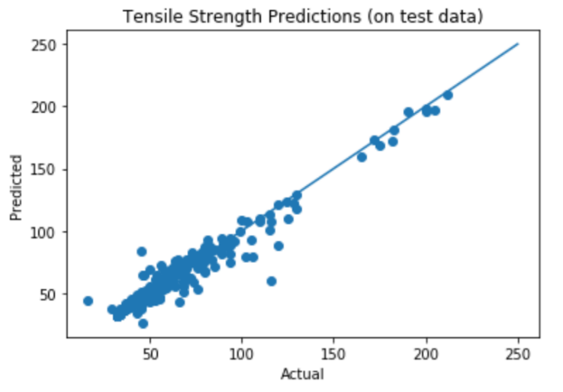 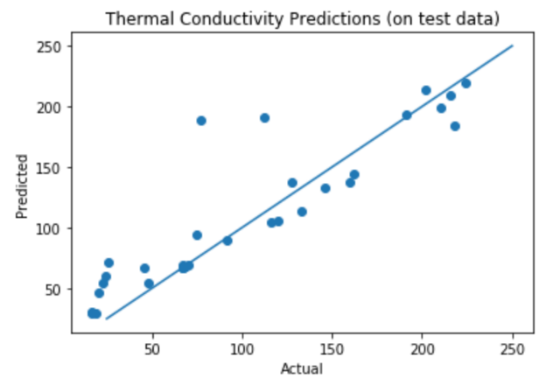

The following table contains the summary of the model performances for both models.

|  |  |  |  |  |
| --- | --- | --- | --- | --- |
| **Target Property** | **10-Fold Cross Validation Score summary** | | | **R-squared**  **score**  **(Test Data)** |
| **Mean R-squared score** | **Median**  **R-squared score** | **Standard Deviation** |
| Tensile Strength | 0.925510 | 0.937542 | 0.035971 | 0.938538 |
| Thermal Conductivity | 0.822672 | 0.838199 | 0.168483 | 0.757116 |

**Analysis of Features’ Importance:**

Random forests model alloys to access a hierarchy of the features which prove to be most useful for predicting each the relevant properties. These importance metrics are represented in descending order of their contribution percentages for both the models (in fig). These values indicate that the features for beryllium and processing factors have a large contribution to determining the tensile strength of a copper alloy. The reliability of these results are affirmed by the excellent performance by the tensile strength model.

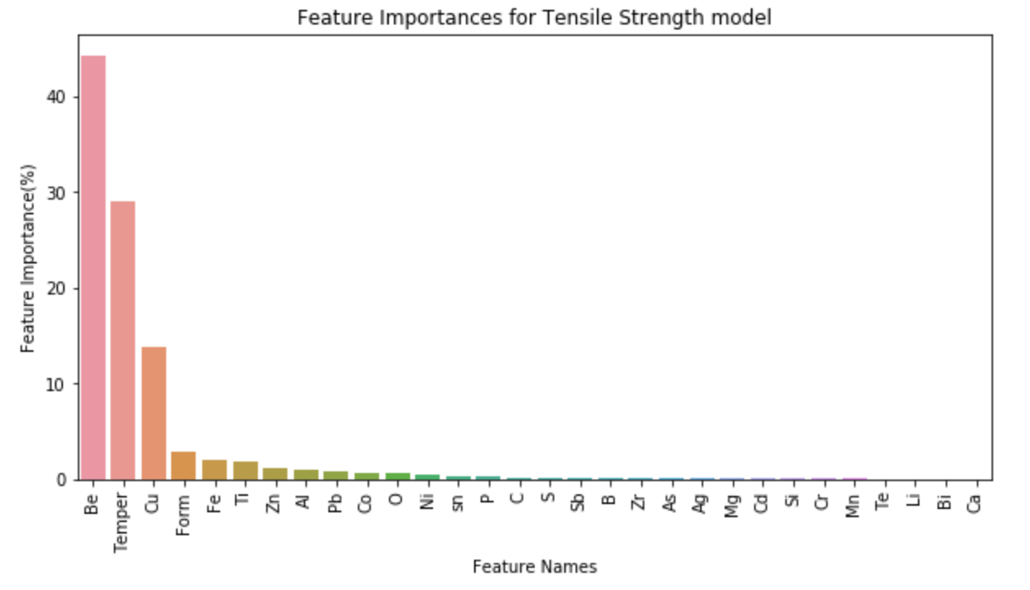

The features’ importance for thermal conductivity prediction are not given much regard in this analysis since the model still has scope for improvement. Nonetheless, the hierarchy of features can be seen in fig

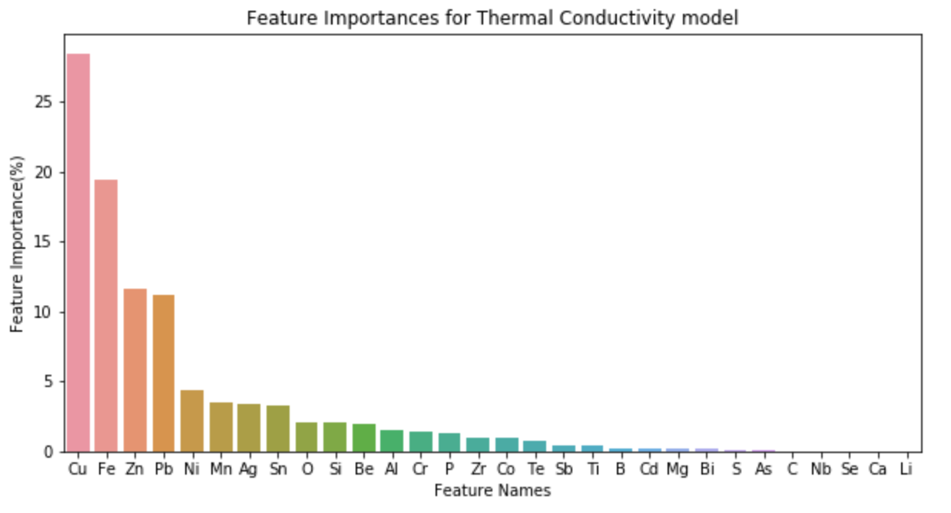

**Results of SAGS system :**

The inversed model (as discussed earlier) generates candidate copper alloys as their a percentage by mass composition of their constituent elements (also, form and temper features in the case of alloy generation using tensile strength) based on a specified target value of tensile strength or thermal conductivity.

The candidate solutions for a few values of both the properties were inspected. This step was challenging because of the lack of an accessible copper alloy data or similar resources. There were multiple instances where the system returned compositions with the selected value of the relevant properties. Moreover, there were also a few cases where the alloys described by the system were not in the training dataset and had the same value of the desired properties, which we were able to verify using the public database.